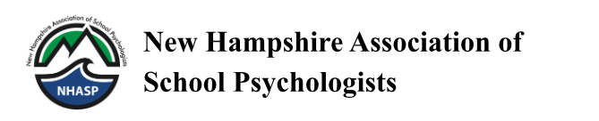
November 13, 2023
Dear NH Colleagues,
As you know, each year our association solicits nominations for the NH School Psychologist of the Year. We encourage you to take a few moments to think about your fellow school psychologists whose daily work makes a positive difference in the lives of children, parents, and educators. Please consider nominating a colleague for this prestigious award if you believe they meet the following criteria:
- Is a current member of the New Hampshire Association of School Psychologists (NHASP) and works primarily in New Hampshire (July 1, 2023 to June 30, 2024).
- Is a practicing school psychologist, associate school psychologist, or licensed psychologist who provides direct services to students, teachers, and parents in school settings.
- Performs job in an exemplary manner.
- Earns the respect of others and is held in high regard by fellow professionals, students, and parents.
- Has involvement or leadership in projects that contribute significantly to the school, community, or profession.
Procedures and Required Documents
- Candidate Contact - The nomination process involves first contacting your nominee to verify that they are a current member of NHASP.
- Nomination Statement - Write a one page nomination statement explaining why the candidate should be considered for this award, including specific examples of exemplary job performance, respect of others, professional membership, and leadership activities.
- Candidate’s Resume or Vita - We will also need a copy of the nominee’s resume or curriculum vitae.
- Two Letters of Support - These should be no more than two pages in length and should be written by individuals knowledgeable about the candidate’s capabilities, professionalism, and leadership qualities. Letters may be provided by administrators, colleagues, parents, or students with whom the candidate has worked.
Nomination materials should be in a 10- or 12-point font for easy reading by the reviewers. Please save materials in Microsoft Word or PDF format. All nomination materials must be submitted in one email. The nominator will receive an email reply confirming receipt. If the packet is missing any of the required documents, it will be considered incomplete and will not be reviewed. Previously submitted nominations may be resubmitted with updated information.
Nomination materials should be submitted by February 24th and emailed to kgrievenhasp@gmail.com.
If you have any questions, please feel free to contact me.

Respectfully submitted,
Kate Grieve
NHASP Past-President

